Exercise 2: E-commerce Platform Search Function

Objective
Develop a search functionality for an e-commerce platform that allows users to find products by name. Compare the performance of Linear Search and Binary Search algorithms.
Product.java
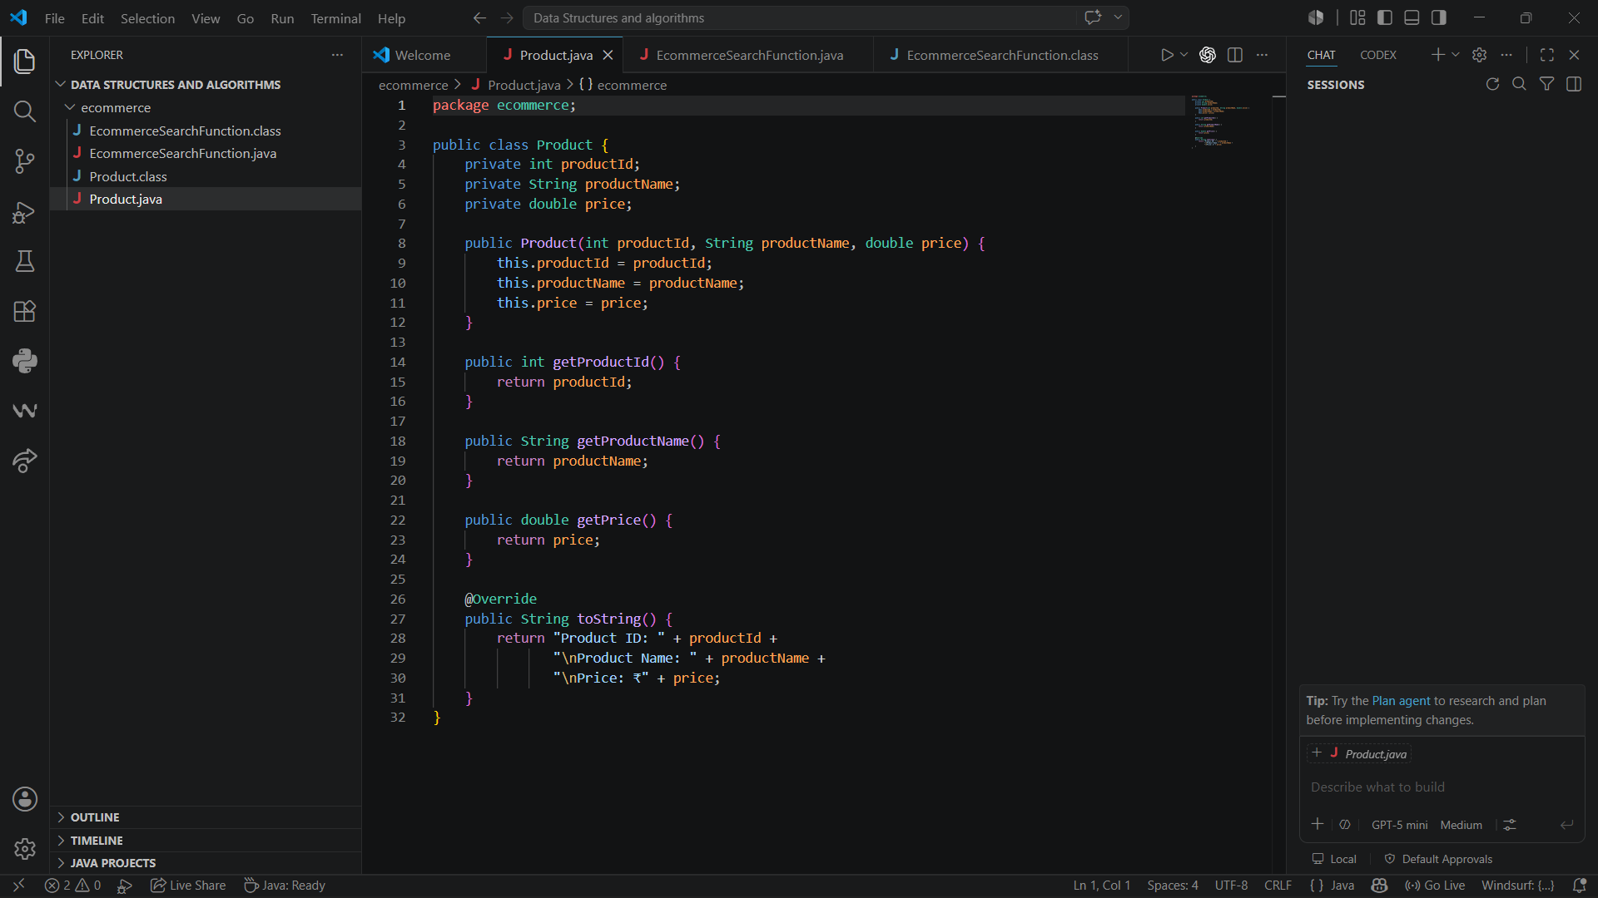
EcommerceSearchFunction.java
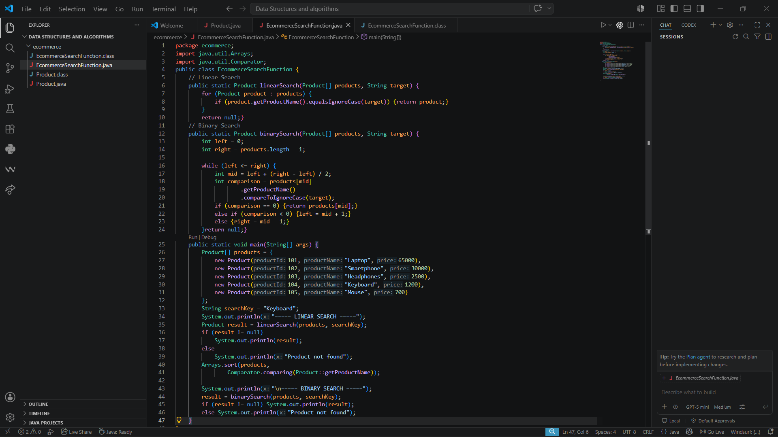

Output:
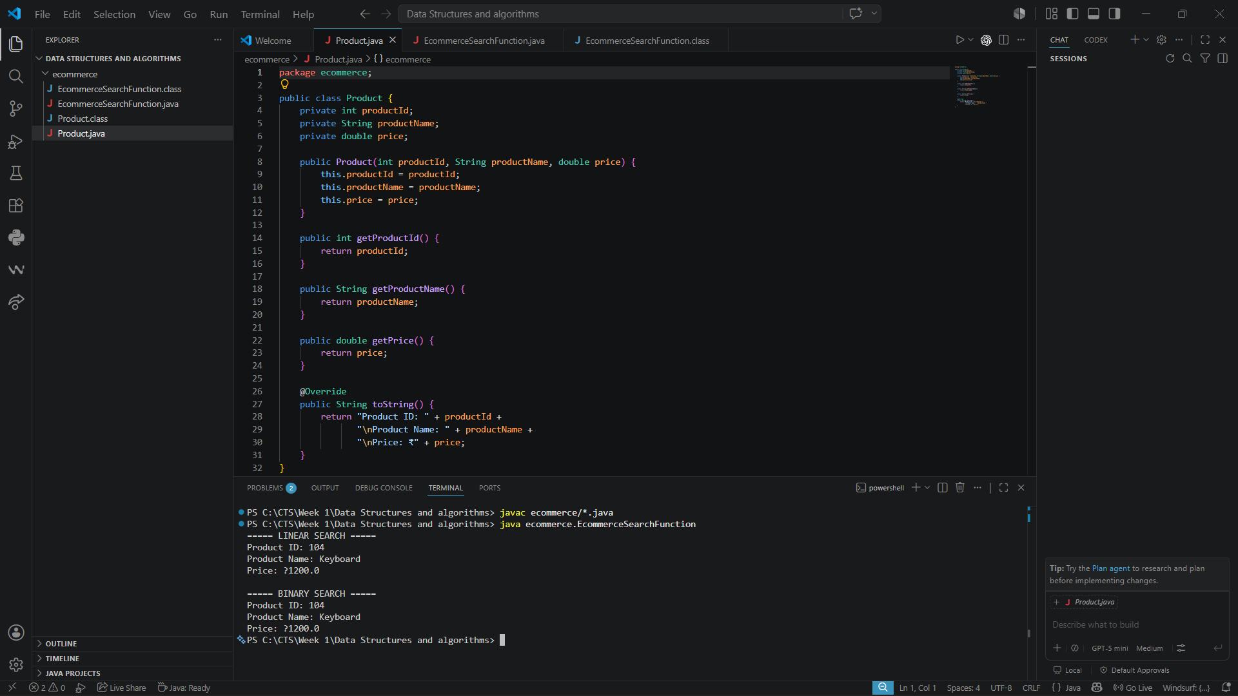

Analysis:

Time Complexity comparison:

Scenario | Linear Search | Binary Search
Best case | O(1) - First element | O(1) - Middle element
Average case | O(n) | O(log n)
Worst case | O(n) | O(log n)

Suitable Algorithm:

Binary search will be more suitable for an E-commerce Search Function. As it works well for large , static product catalogs that can be sorted by productId.

